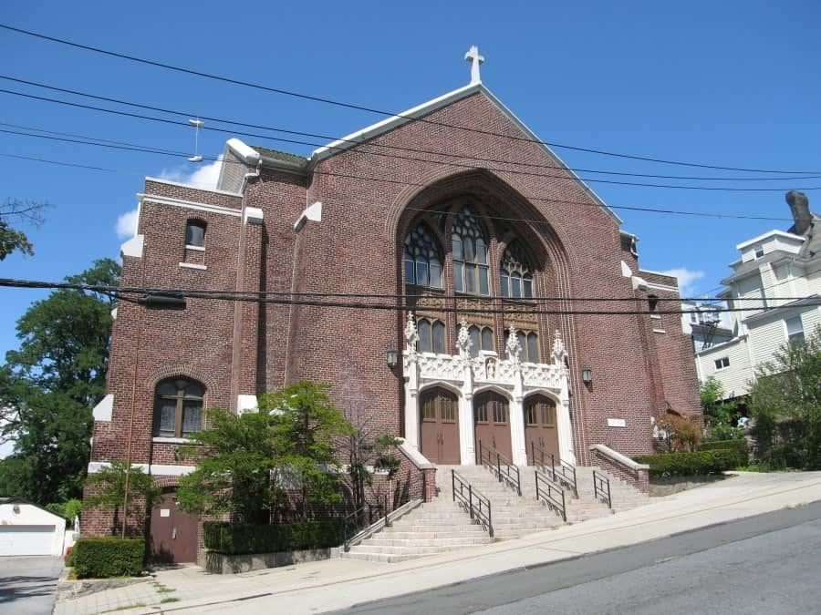

MINIMUM CAPACITY :-
The Minumum intake capacity
of students is between 300-620
children

LIBRARY :-
The Libarary is Available.

CANTEEN:-
The Canteen Facility is Available.

BOARDING :-
No availablility of boarding.

SPORTS :-
There are different categories
sports available.
Girls Volleyball
Boys Volleyball
Football

CHARTER SCHOOL OF EDUCATIONAL EXCELLENCE
YONKERS - SCHOOL

School Detail :-
The Charter School of Educational Excellence's mission is to develop students who are critical thinkers, motivated leaders, and lifelong learners. We are committed to a strong partnership with our teachers, parents, community and alumni.

